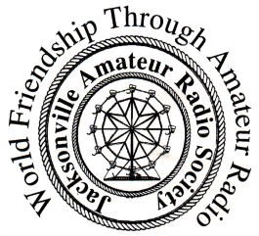 |  | Jacksonville Amateur Radio Society  Application for Membership / Renewal  Items marked with * are required
 |  | *First Name: |  |  |  |  |  | *Last Name:
 |  | *Address: |  |  |  |  |  | *City: |  | *State: | *Zip:
 |  | *Call Sign: |  |  | *License Class: |  |  |  | Email:
 |  | *Phone # :  ( ) - |  |  |  |  |  | □ Check here if you do not want your information listed in the club roster. |  | □ Email forwarding?  (callsign@k9jx.org)
(Check One) Type of Membership |  |  |  |  |  | (Check if it applies)
 | Individual Membership $25.00 |  |  |  |  |  | ARRL Member
 | Family Membership $30.00 |  |  |  |  |  | ARES Member
 | Student / Associate Membership $10.00 |  |  |  |  |  | RACES Member
(Check One) |  |  |  |  |  |  | NTS Traffic
 | New Membership |  |  |  |  |  | Skywarn Trained
 | Renewal |  |  |  |  |  | Other Clubs:
What are your general amateur interests?

What would you like covered during a club presentation?

Make Checks Payable To:  Jacksonville Amateur Radio Society |  |  | For more information about the Jacksonville Amateur Radio  Society see our website at K9JX.org or email info@k9jx.org  Club meetings are on the first Friday of each month at 7:00pm. We meet at Christ Lutheran Church of the Deaf (104 Finley St.) in Jacksonville, IL  Membership is valid from July through June.
Mail To:
Jacksonville Amateur Radio Society Treasurer
C/O Tom Phillips
230 Caldwell St. Jacksonville, Illinois 62650
Jacksonville Amateur Radio Society JARS Membership Application – Rev. 5/5/2022

